Karnataka Valuation & E-Registration (KAVERI - 2.0)
Government of Karnataka

Functional Requirement Specifications

For KAVERI 2.0
Department of Stamps & Registration
Government of Karnataka
Version 1.0
October 22, 2024

Pre-registration scrutiny
(Round-robin method)

Prepared by
Centre for Smart Governance (CSG)
2nd Floor, TTMC Yeshwanthapura, BMTC Bus station
Bangalore – 560022

Contents
Pre-registration scrutiny (Round-robin method) 4
2. Introduction 4
3. Document scope 4
4. Overview of the function 5
4.1. Interaction diagram: Round-robin SRO for scrutiny 5
5. Description of the functional requirement 7
5.1. Actors and their roles 7
5.2. Use case 8
5.3. Workflow 9
5.4. Validations 10
5.5. Wireframes 10
5.6. Integration with other systems/modules 10
5.7. Assumptions 10
5.8. Dependencies 10
6. Annexures 11
6.1. Annexure – 1 – List of modules of Kaveri 2.0 11
6.2. Annexure- 2 – Requirements as shared by the Department 13
6.3. Annexure – 3 – Clarificatory questions 13
6.4. Annexure – 4 – Document Summary 14

Acronyms
CSG | Centre for Smart Governance
DR | District-Registrar
FDA | First division assistant
SR | Sub-Registrar
SRO | Sub-Registrar Office
SDA | Second division assistant

Revision History
Date | Version | Prepared by | Reviewed by | Approved by | Description
22/10/2024 | 1.0 | Arugolli Subhash (CSG) | Rajesh Hanbal (CSG) | To be approved | Submitted for approval of the nodal officer of the department

Introduction
The Department of Stamps and Registration (henceforth referred to as “department”) is the custodian of registered public records such as Registration of Marriages and Firms, Documents about transactions namely sale, transfer or gift of immovable properties, Mortgage, Power of Attorney, wills, and many more. Maintenance and preservation of these critical public records is the prime responsibility of the department. The records or the information associated with registered records are to be made available to the public when requested through defined procedures. The department is also responsible for collecting stamp duty on behalf of the government for specified transactions. The services are provided through 258 Sub-Registrar Offices (SROs), under the supervision of 35 District Registrar Offices, spread across the state.
The department has computerized the delivery of these services through the development of Kaveri software. The KAVERI Online service is a web-based application of the department that provides an interface to the applicants required for documents, marriage, and firm registration. It enables applicants to know the details of stamp duty, property guidelines value, data entry for document registration and marriage registration, etc. The list of modules in Kaveri 2.0 is available in Annexure 1.

Document scope
This document is a Functional Requirement Specification (FRS) describing the functional feature of the pre-registration scrutiny (round-robin method) in Kaveri 2.0. The document is prepared by the Centre for Smart Governance (CSG) and has been submitted for department approval. The intended audience of the document is the departmental approving authority and the development team.
The document was prepared through document analysis and departmental consultation. The department shared the high-level requirements (Annexure -2)

Overview of the function
Round-robin SRO allocation
Document Registration

Fig: Pre-registration scrutiny (Round-robin method) function in Document registration.

Interaction diagram: Round-robin SRO for scrutiny

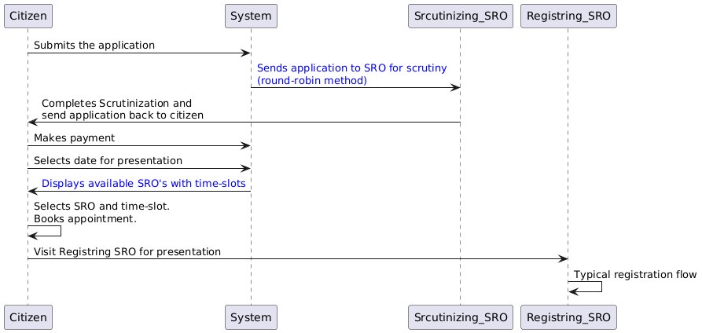
Under the existing system, applicants for document registration are allowed to select the Sub-Registrar Office (SRO) during the application submission phase based on the index village of the property. With the feature of “anywhere registration”, the applicant can select any of the SROs within the registration district for application scrutiny and registration.
Importantly, the scrutiny process is conducted electronically via the Kaveri portal, thereby eliminating the need for applicants to physically visit the selected SRO. However, this system does not account for the real-time availability, workload, or operational capacity of each SRO. As a result, certain SROs within a district experience disproportionate burdens, causing undue delays in service delivery and adversely impacting the quality and efficiency of operations.
Proposed Solution – Introduction of the Round-Robin Method:
To address the imbalanced distribution of applications and to ensure the equitable allocation of workloads at the scrutiny level across all available SROs, the Round-Robin Method is proposed as a new allocation method. Under this model:
- Automatic and equal allocation: Applications will no longer be assigned based on the applicant’s discretion at the scrutiny stage. Instead, the system will automatically allocate applications sequentially among all available SROs in the district in a rotational order, ensuring uniform distribution of workloads. The Round-Robin mechanism will prevent any single SRO from becoming disproportionately burdened, thereby mitigating service delays and maintaining the quality and efficiency of scrutiny.
- Date selection: Following the scrutiny of the application, the applicant shall make the payment. Upon successful completion of the payment, a dropdown will be displayed, listing the available dates of all the SROs within the registration district.
- Time selection: The applicant shall select an SRO and a time slot available and confirm the appointment for the presentation of documents. On the scheduled date and time, the applicant is required to personally appear at the selected SRO for the submission and formal presentation of the documents.

Description of the functional requirement

Actors and their roles

Actor/Interface | Role/Responsibilities
Applicant | - Submits the application  - Makes payment  - Selects time-slot  - Select SRO for presentation  - Visits SRO on appointment day
System | - Sends the application to SRO for scrutiny (round-robin method)  - Sends the scrutinized application to the applicant for payment  - Confirms the payment  - Displays the available time-slots  - Displays the available SROs to book an appointment  - Confirm and schedule the appointment
Scrutinizing SRO | - Receives the application  - Verifies the application  - Calculates the market valuation and stamp duty fee
Registering SRO | - Receives the application  - Typical registration flow (presentation flow)
Process Triggers | - Citizen submits the application for document registration
Data/Information Required | - NA
Output documents generated | - Document summary  The summary must contain the note of the scrutinized SRO name
Internal changes | - NA
Impact on other modules | - NA

Use case
For example, Ramanagara district comprises four Sub-Registrar Offices (SROs): Ramanagara, Channapatna, Kanakapura, and Magadi. Across these offices, a total of five Sub-Registrars (SRs) are working, as explained below:
SRO Office | Number of SRs
Ramanagara | 2
Channapatna | 1
Kanakapura | 1
Magadi | 1

Application No | SRO allotted for scrutiny
1 | Ramanagara
2 | Ramanagara
3 | Channapatna
4 | Kanakapura
5 | Magadi
6 | Ramanagara
7 | Ramanagara
8 | Channapatna
9 | Kanakapura
10 | Magadi
Allocation of the application using the weighted round-robin method:
The five SRs across the district are assigned applications sequentially, with one application per SR in each round of five applications to maintain equitable distribution.
- Multiple allocations to Ramanagara SRO:
- Ramanagara has two SRs each receiving one of two consecutive applications during every cycle.
- After handling two applications, the system moves to the next SRO.
- Other SROs (Channapatna, Kanakapura, Magadi):
- Each of these offices has one SR. As a result, each receives one application every 5th round, maintaining a uniform distribution across the district.
- Operational Efficiency:
- This method ensures that SROs with more SRs (like Ramanagara) receive an equitable number of applications, optimizing their capacity, while smaller offices still handle a fair share of the workload.
- Under the previous system, the distribution of applications was determined at the discretion of the applicant during the scrutiny stage. As a consequence, certain Sub-Registrar Offices (SROs) experienced a disproportionate workload. For instance, the Ramanagara SRO, being the district headquarters, attracted a higher volume of applications, leading to an inequitable distribution of work. Conversely, other SROs in the district, namely Channapatna, Kanakapura, and Magadi, remained underutilized due to the relatively lower number of applications assigned to them.

Workflow

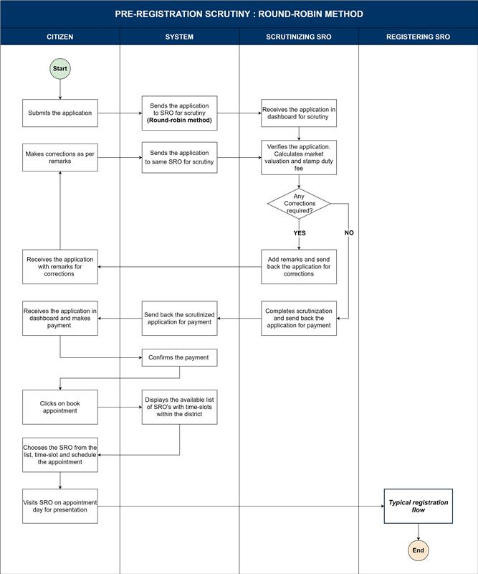

Validations

- The system must send the application to the SRO within the selected district using the round-robin method.
- The system must display the available time slots for each SRO within the selected district during the appointment booking process.
- The system must resend the application to the same SRO who initially scrutinized it when the application is returned by the applicant with corrections.

Wireframes
https://www.figma.com/proto/XXr1AJjPcmTqqWK6zMBVQo/Untitled?page-id=0%3A1&node-id=1-735&node-type=frame&viewport=-5787%2C167%2C0.27&t=9B1KAn2AdTim8vXq-1&scaling=contain&content-scaling=fixed&starting-point-node-id=1%3A73

Integration with other systems/modules

External integration
NA

Internal integration with other modules
NA

Assumptions
The DR can assign the responsibility of scrutiny to the FDA/SDA within the same SRO in the absence of the SR.

Dependencies

No dependencies

Annexures

Annexure – 1 – List of modules of Kaveri 2.0

Sl No | Module No | Main Module | Sub-Module
1 | 1.1 | Registration | Registration
2 | 1.2 | Registration | Appointment
3 | 1.3 | Registration | Integration module
4 | 1.4 | Registration | Stamp duty and Registration fee calculation
5 | 1.5 | Registration | Guideline value calculation
6 | 1.6 | Registration | Rule 17 (2) filing
7 | 1.7 | Registration | Rule 17 (3) filing
8 | 1.8 | Registration | Old pending release module
9 | 1.9 | Registration | Re-Registration module
10 | 1.1 | Registration | Will after Death
11 | 1.11 | Registration | Filing documents (FRUITS)
12 | 1.12 | Registration | Scanning
13 | 1.13 | Registration | Memo transmission and filing
14 | 1.14 | Registration | 68(2) correction
15 | 1.15 | Registration | Cross-reference Rule 123
16 | 1.16 | Registration | Integration exemption
17 | 1.17 | Registration | Court entry
18 | 1.18 | Registration | Liability
19 | 1.19 | Registration | Status tracking
20 | 1.2 | Registration | Investigation and Search
21 | 1.21 | Registration | Valuation Module (CVC)
22 | 2 | EC
23 | 3 | CC
24 | 4 | Verify Document
25 | 5 | Power of attorney Authentication Module
26 | 6 | Refund Module
27 | 7.1 | Marriage | Hindu Marriage
28 | 7.2 | Marriage | Special Marriage
29 | 7.3 | Marriage | Special Marriage in Other Forms
30 | 8 | Legacy Record digitisation
31 | 9 | Audit
32 | 10 | Accounts
33 | 11.1 | MIS | Statutory (44)
34 | 11.2 | MIS | Statistical (54)
35 | 11.3 | MIS | Integration (15)
36 | 11.4 | MIS | Computer related (4)
37 | 11.5 | MIS | Reconciliation (5)
38 | 11.6 | MIS | HR (5)
39 | 12.1 | DRO | Firm Registration
40 | 12.2 | DRO | Undervaluation
41 | 12.3 | DRO | Deposit of will
42 | 12.4 | DRO | Adjudication of documents
43 | 13 | IGRO | Appeal
44 | 14 | Master Data Management
45 | 15 | User Management
46 | 16 | Mobile application
47 | 17 | Training Module | Master Trainer, Training Plan

Annexure- 2 – Requirements as shared by the department
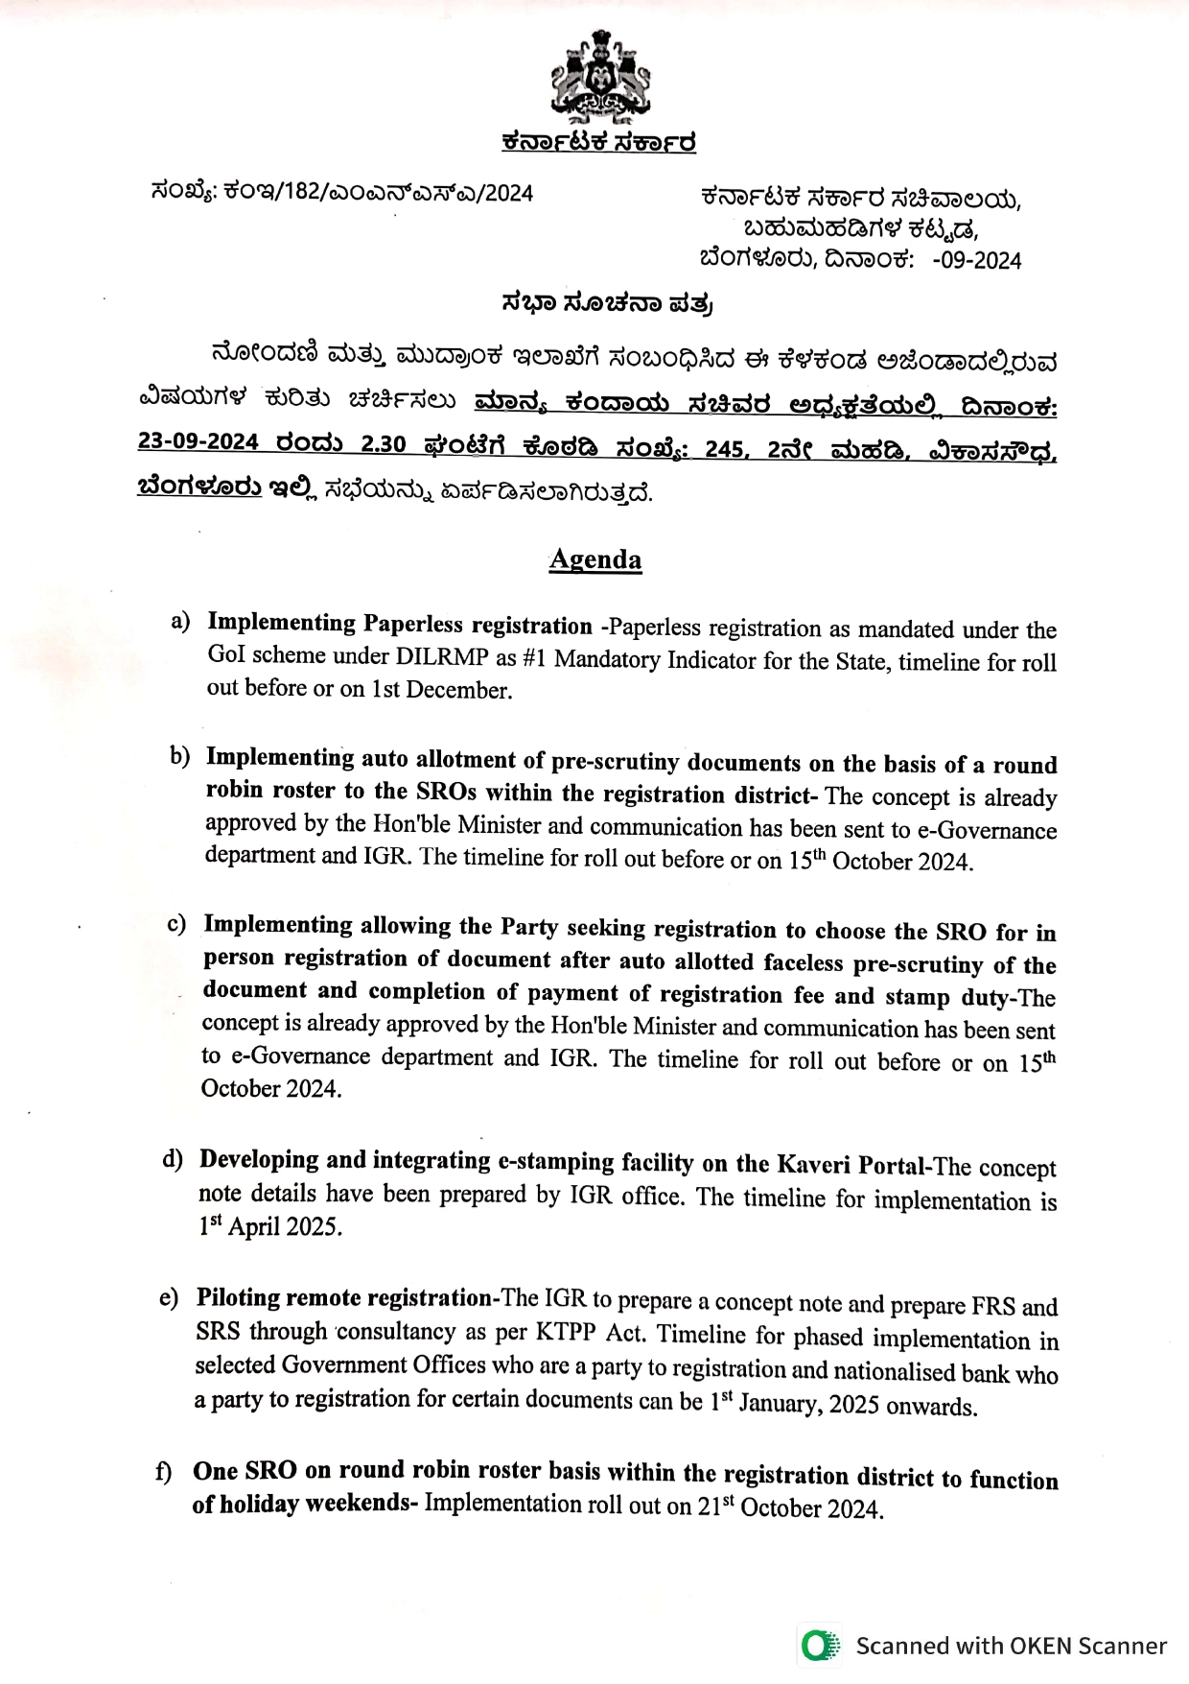

Annexure – 3 – Clarificatory questions
- Is any statistical MIS report generation required?

Annexure – 4 – Document Summary
